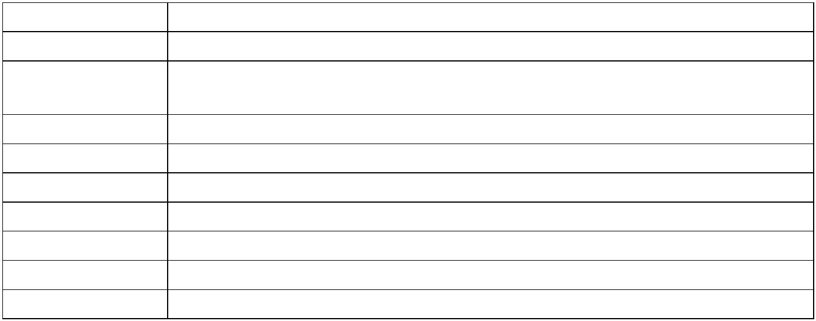
Suntek Interview Question
Problem Description： A room sharing company (e.g., Airbnb) wants to help room providers set
a reasonable price for their rooms. One of the key steps is to build a model to predict the
purchase probability of a room (described by certain features as well as the date) under certain
prices. We have the following historic data:
ID The data ID
Region The region the room belongs to (an integer, taking value between 1 and 10) Date The date of stay (an integer between 1‐365, here we consider only one‐day
request)
Weekday Day of week (an integer between 1‐7)
Apartment/Room Whether the room is a whole apartment (1) or just a room (0) #Beds The number of beds in the room (an integer between 1‐4)
Review Average review of the seller (a continuous variable between 1 and 5)
Pic Quality Quality of the picture of the room (a continuous variable between 0 and 1)
Price The historic posted price of the room (a continuous variable)
Accept Whether this post gets accepted (someone took it, 1) or not (0) in the end
The training data is posted at: http://www.menet.umn.edu/~zwang/files/case2_training.csv
The testing data is posted at: http://www.menet.umn.edu/~zwang/files/case2_testing.csv
(There are 50,000 training and 20,000 testing data.)

Goal： Build a model to predict the purchase probability of each test data. We will evaluate the
model by the AUC of your result (thus please give a probability for each test data).
Format of the answer: Please send back the following items to jennyqi000@gmail.com
1) The prediction result: A csv file containing the result. To make the file smaller, you only need
to keep the ID and answer columns (which’s column names are [ID, possibility]), please do not include index column.
2) The code you used to produce the answer. Python code is preferred. However, R or other
languages are also acceptable. We would encourage you to use ipynb format with python and rmd format with R, in order to keep your data visualization and plot image. The whole project should be confined in one document and is with your code annotation (We do not like raw code).
3) A short description of your approach (no more than one page) and the main findings in your
analysis. If you did not use language above, put your image on the description.
4)The final loss rate or AUC would be an important part for the interview result.
Finally, Good Luck with U !

